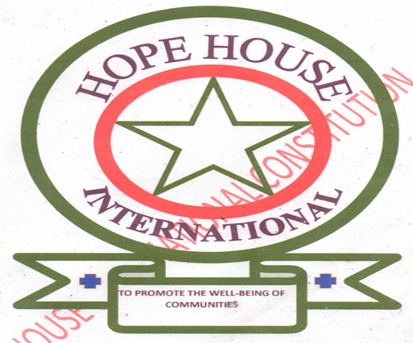



HOPE HOUSE INTERNATIONAL: PROFILE

**INTRODUCTION AND BACKGROUND**

**Founder: BISHOP PETER YUOL GUR**

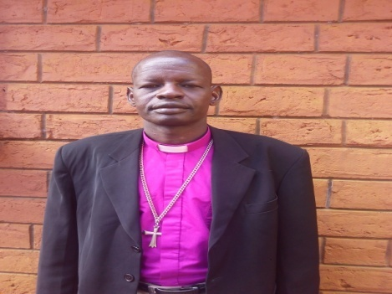Hope House International is a children’s home based in Kitale, Kenya founded in 2009 by Bishop Rev Peter Yuol Gur from Tonj, South Sudan. The facility houses 38 children and youth aged between 4 to 18years.This comprises of 13 girls and 25 boys. What began as support for two young boys namely Gabriel T. Dak and Joseph M. Madhang, is evolving into a growing family of predominantly vulnerable children from South Sudan.

Upon completing his studies at St. Paul University, Limuru-Kenya, the founder, Rev. Peter Yuol went to work back to South Sudan to commence work as diocesan secretary at Wau Diocese. He later travelled to United Kingdom to solicit financial support for from his friends for vulnerable children. More information about his work can be found at [www.angelican.tonj.org](http://www.angelican.tonj.org)

**CURRENT MANAGEMENT**

Upon the exit of BISHOP Rev. PETER YUOL GUR, and from the beginning of 2014, the home has been under the Directorship of Gabriel T. Dak, a home he joined since his childhood in 2009. Gabriel functions as the In-charge and Home Coordinator who has over time developed excellent leadership skills.

Under his leadership, the home has grown from 14 children when he took over to the current 38 children with support from local friends and a few international sponsors.

Bishop Peter Yuol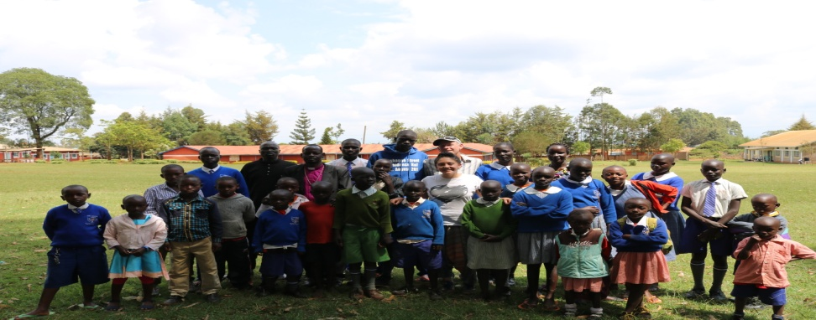,His wife Deborah Akuc Peter,his friends from UK-Dr. Clive Kelly and Sally in 2017.

**SUCCESS STORY**

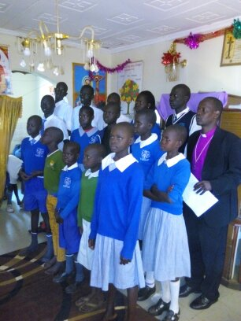Being visionary, Gabriel has spearheaded the acquisition of a piece of land back in Wau, South Sudan where we plan to move by the beginning of 2023. He is now a Director and Coordinator with a goal to have working team under him soon as he keeps his great commitment to do more tasks that better Hope House.

Bishop Peter Yuol during a visit to the home with some of the children in 2014.

In addition, the home is pleased to announce that 3 of the children scored grade B+ in the last academic year and two of the three have secured scholarships overseas (Canada and United States of America) with the assistance of UNHCR.

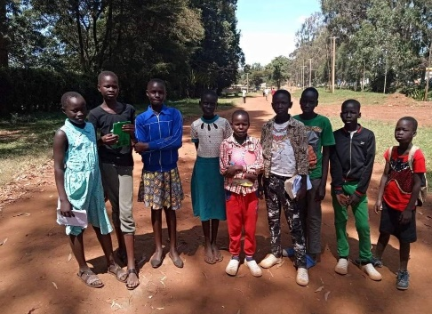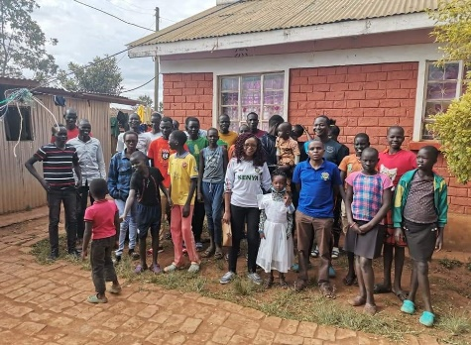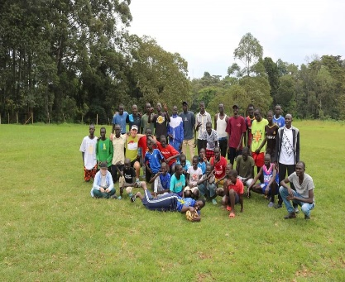

**CALL TO ACTION**

In order to strengthen management structures of the Home and enact sustainable programs for effective functioning, the leadership is mobilizing resources in cash and kind from local and international sources. We have also developed partnerships and collaborations with relevant stakeholders to increase our visibility in the community. In addition, we are in discussion with well- meaning professionals on pro-bono basis to help us develop working tools including organizational policies relevant to our sector.

Recurrent and Personal expenses for sustenance continue to remain a challenge including: Buildings and constructions, School fees, Food, rent, clothes, beddings and medicals among others.

**Propose School in Wau, South Sudan.**

We are requesting our wishers, donors and partners to support this course. Our prayers and hope are to see this establishment due by the beginning of January,2023 in order to facilitate our move and return to our own home country as we our desires arises.

**Contact**

**Gabriel T. Dak**

**Director,Hope House.**

**+211922225303**

**dakmonytur@gmail.com**